HTML Meta Tag

## **Meta Tag**

**HTML meta tags** or **metadata** are used to add metadata to a webpage. Usually **meta tags** are defined in **<head> tag** as these data are for search engines. **Meta Tags**were earlier known as **meta tags**, but in [HTML5](https://tutorial.techaltum.com/html5.html), the new name is **metadata**.

**Meta tags** are used in head to add **meta charset**, **meta description**, **meta viewport**, **meta open graph** etc.

### **Meta Tag example**

<meta>

## **Meta Charset**

**meta charset** is used to specify the **character encoding** of webpage. It is compulsory to declare meta charset in a webpage.

For Windows OS, the default value for **meta charset** is **windows-1252**.

**UTF-8** or **Unicode Transformation Format** is the the most popular charset. **UTF-8** can render almost all characters like alphabets, numbers, greek, devnagri, spanish, french, chinese etc. **UTF-8** is also the default charset of **Chrome Browser**.

### **Meta charset**

<meta charset="utf-8">

As per W3C, meta charset is compulsory in a webpage.

## **Meta Description**

**Meta description** is the metadata used to declare **description for search engines**. Almost all search engines used **meta description** to know **description of a webpage**.

It is recommended to used **meta description** in head for search engines. The recommended character length for **meta description**is 160 characters.

### **Meta Description example**

<meta name="description" content="type your description here">

## **Meta Viewport**

**Meta Viewport** is used in head. **Viewport** means the visible part of screen on any device.

**Meta viewport** is used in [Responsive Web Design](https://tutorial.techaltum.com/responsive-webdesign.html) to control the width, scaling and user scablility.

Without viewport, browser display a webpage as per the actual screen size. But **meta viewport** adjust the screen fonts as per the device pixel ratio. This means, we can see same desktop font on mobile device without zooming.

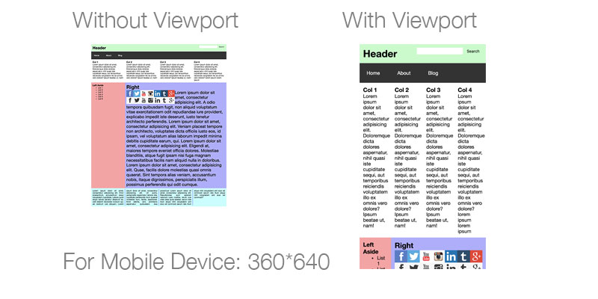meta viewport

### **Meta Viewport Examaple**

#### **Viewport for most of the sites**

<meta name="viewport" content="width=device-width, initial-scale=1.0">

#### **Viewport for the sites with no zoom**

<meta name="viewport" content="width=device-width, initial-scale=1, maximum-scale=1, user-scalable=no">

### **Viewport Width Vs Actual Width**

| Viewport Width Vs Actual Width | | |
| --- | --- | --- |
| Device | Viewport Size | Actual Size |
| Iphone X | 375*812 | 1125*2436 |
| Iphone 8 Plus | 414*736 | 1080*1920 |
| Iphone 8 | 375*667 | 750*1334 |
| Ipad (9.7 inch) | 768*1024 | 1536*2048 |
| Samsung Galaxy S8, S9 | 360*740 | 1440*2960 |
| Macbook Pro (13 inch) | 1280*800 | 2560*1600 |